Multivariate Analysis

# Shape Features

| For each  Nucleus (A),  Cytoplasm (B) | **'area', 'extent', 'solidity', 'RAN', 'convexity', perimeter, 'major_axis', minor_axis, equivalent_diameter, 'radial_distance_maxN', 'radial_distance_mean, 'radial_distance_sd', eccentricity, circularity, RI, 'radial_distance_Entropia, 'radial_distance_kurtose',**  **Use_curv1,Use_curv2, 'Use_curv3, major_axis_angle** |
| --- | --- |
| For each  Cell (C) | **area_NC', 'perimetro_NC', 'major_axis_NC', 'minor_axis_NC', 'nucleus_position, sub_major_axis_angle_NC',convexity_NC'** |

The following procedure was executed in Python to reduce the amount of variables, as follow:

* Correlation matrix analysis to exclude features with high degree of correlated values in each group: Nucleus, Cytoplasm, Cell
* Analysis of boxplots for the remaining features and their values distributed per Bethesda classes. All features with similar distribution among normal and grade classes, confirmed by a T-Test, was excluded.
* Analysis of a pairwise distribution of all remaining features from nuclei, cytoplasm and cells groups together.
* Classification using a KNN

## Núcleus features

### Correlation matrix analysis

## 

**Consideration:** for each group of features highly correlated (> 90% ) the highlighted feature was selected, all others were excluded.

* **area**, perimeter, major_axis, equivalent_diameter, radial_distance_max ,radial_distance_mean.
* **extent** (Ratio of pixels in the region to pixels in the total bounding box), solidity (Ratio of pixels in the region to pixels of the convex hull image), circularity (perimeter^2/(4pi*Area)), RI (rugosity index).
* **RAN** (ration between: sum of radial distances bigger than mean / (N * mean radial distance), radial distance standard dev, eccentricity (convex Hull perimeter /perimeter)

### Boxplots distribution per Bethesda classes

### 

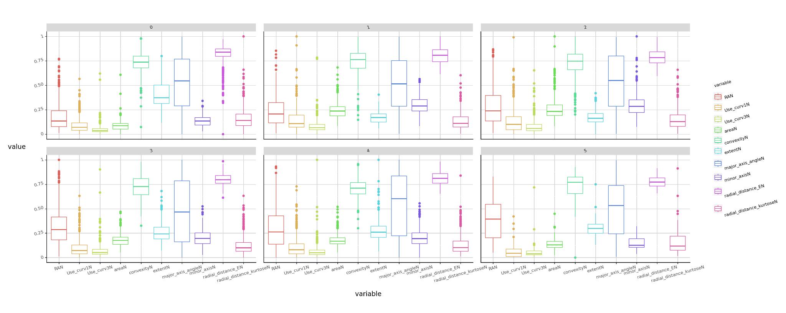

### T-Test

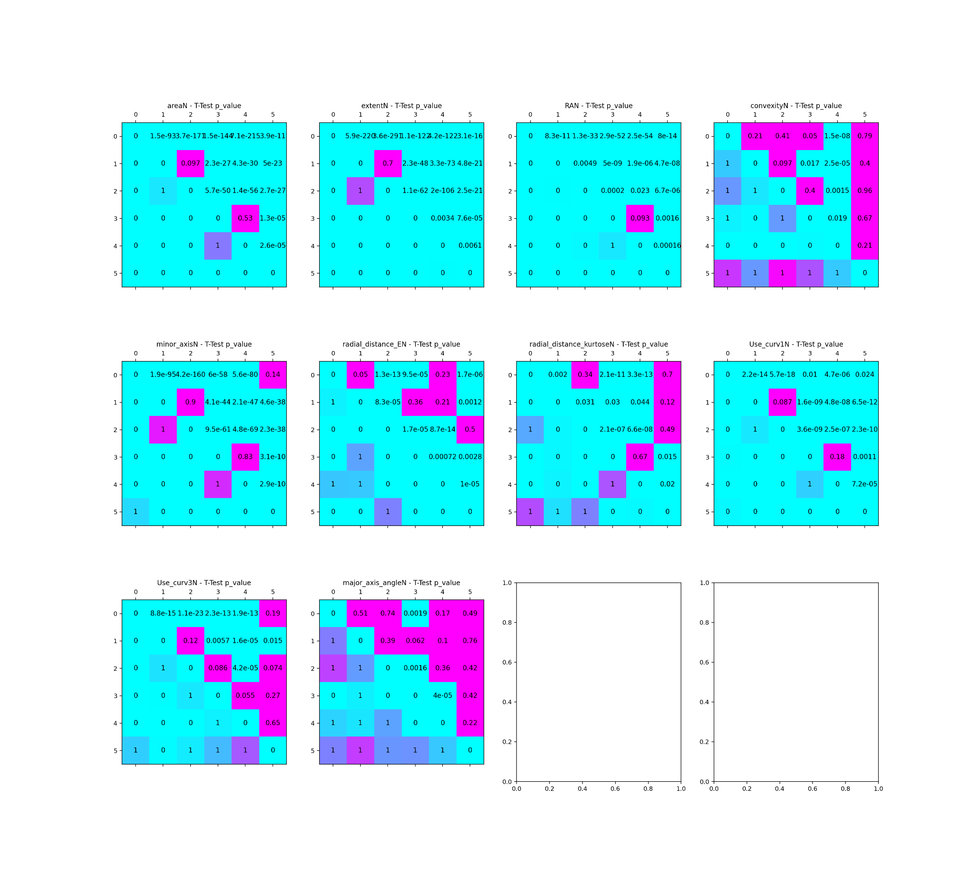

**Consideration:** the follow attribute will be excluded to avoid confusions among normal and abnormal cells or among low grade lesions and high grade lesions

* 1. Convexity: 0(Normal), 1 (ASCUS), 2(LSIL), 3(ASCH), 5(SCC)
  2. Minor_axis: 0(Normal), 5(SCC)
  3. radial_distance_Entropy: 2(LSIL) e 5 (SCC)
  4. radial_distance_kurtose: 1(ASCUS) e 4(HSIL)
  5. Use_curv3
  6. major_axis_angle

### **Nucleus** features selected:

#### area,

#### extent Ratio of pixels in the region to pixels in the total bounding box

#### RA Sum of radial distances bigger than mean distance / (N * mean distance)

1. Use_curv1 the circle area having the same radio of the curvature divided by the area

### 

## Cytoplasm features

### Correlation matrix analysis

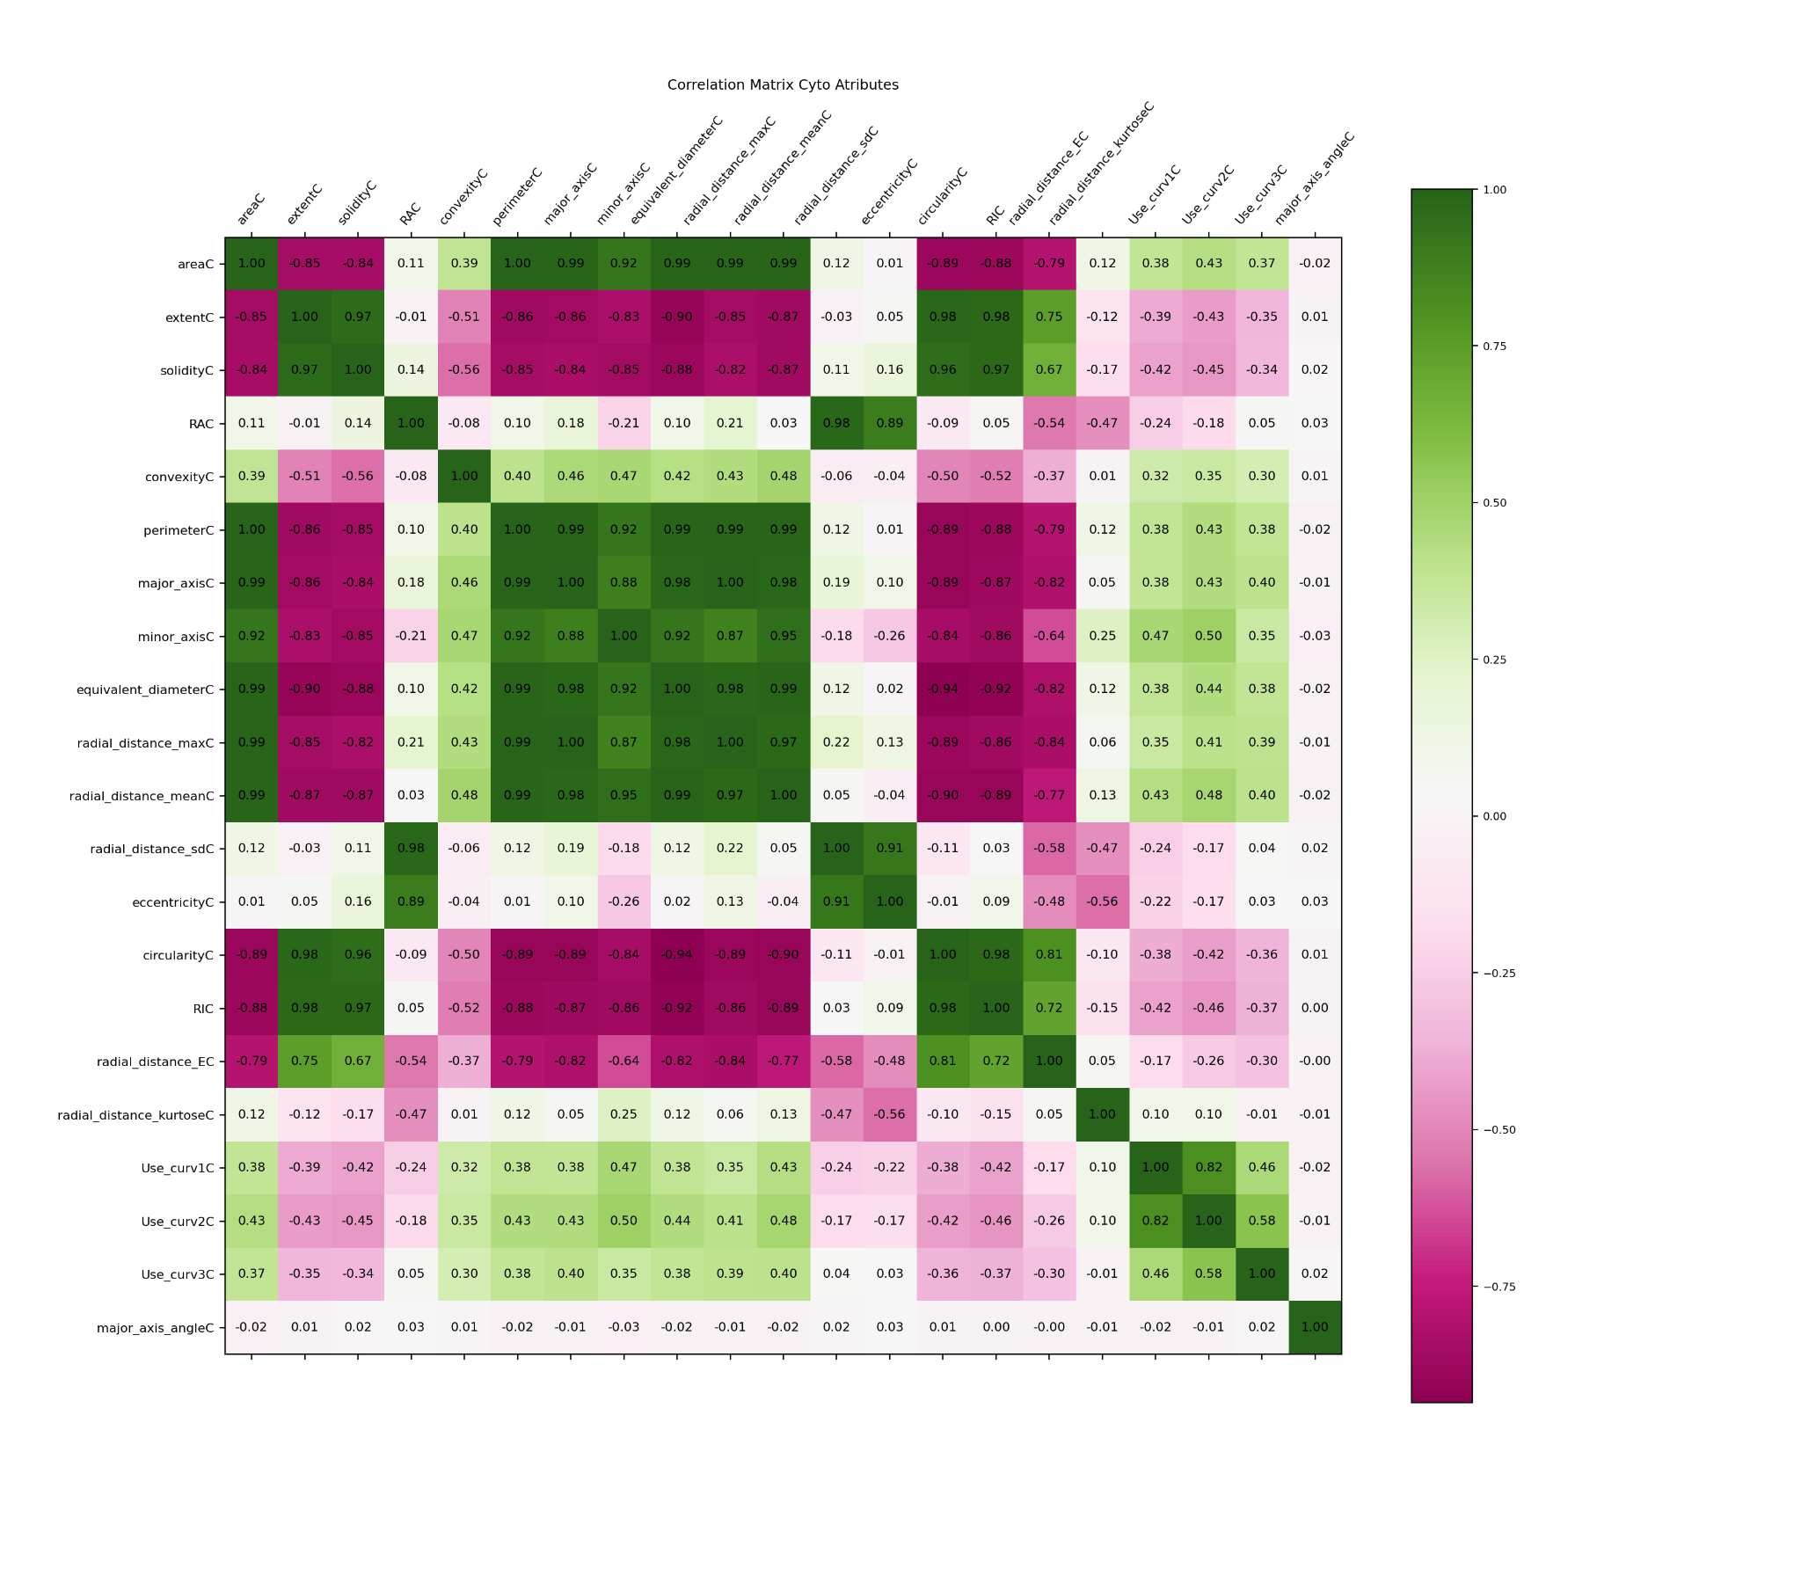

**Consideration:** here we observed the same pattern of nucleus matrix. Again, for each group of features highly correlated (> 82% ), the highlighted feature was selected, all others were excluded.

1. **major_axis,** area, perimeter, equivalent_diameter, radial_distance_max, radial_distance_mean.
2. **solidity**, extent, (Ratio of pixels in the region to pixels of the convex hull image), circularidade (p^2/($pi*A)), RI (rugosity index).
3. **eccentricity** (perimetro_convexHull/perimetro), RA, radial_distance_sd,
4. **Use_curv1**, Use_curv2.

### Boxplots distribution per Bethesda classes

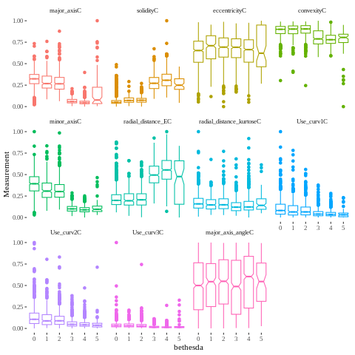

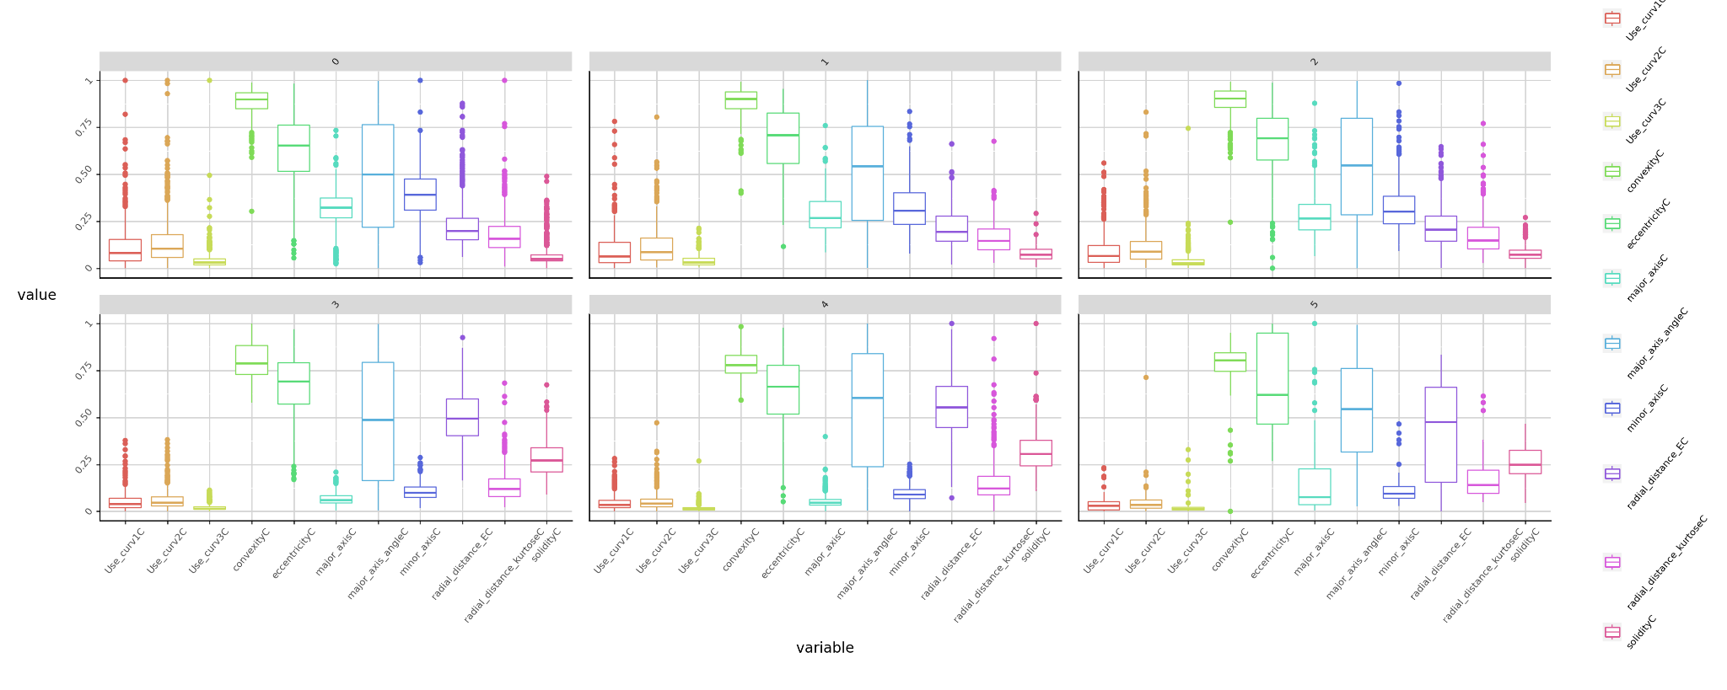

### T-Test

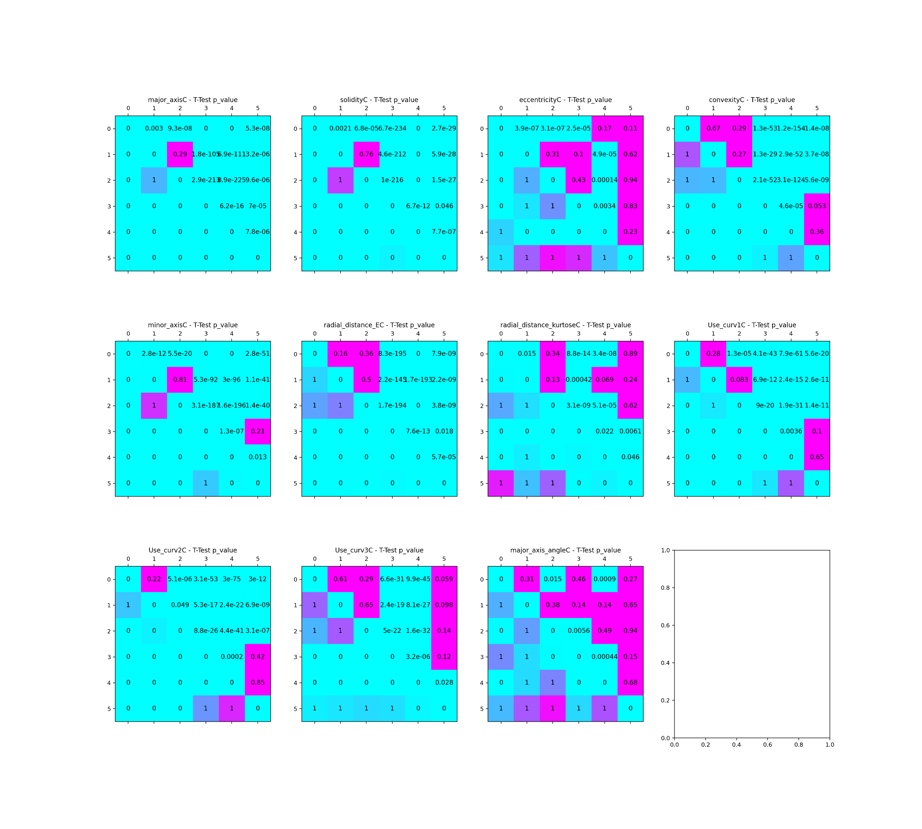

**Consideration:** the follow attribute will be excluded to avoid confusions among normal and abnormal cells or among low grade lesions and high grade lesions

1. eccentricity
2. convexity
3. minor_axis
4. radial_distance_entropy
5. radial_distance_kurtose
6. Use_curv1, Use_curv2, Use_curv3
7. major_axis_angle

The remaining features presents similar distributions among NILM and Low grade classes (e.g. 'major_axis', 'solidity , 'minor_axis)

### **Cytoplasm** features selected still presents similar distributions among normal and low grade classes

#### solidity (Ratio of pixels in the region to pixels of the convex hull image)

#### major axis

#### 

## Cells features

### Correlation matrix analysis

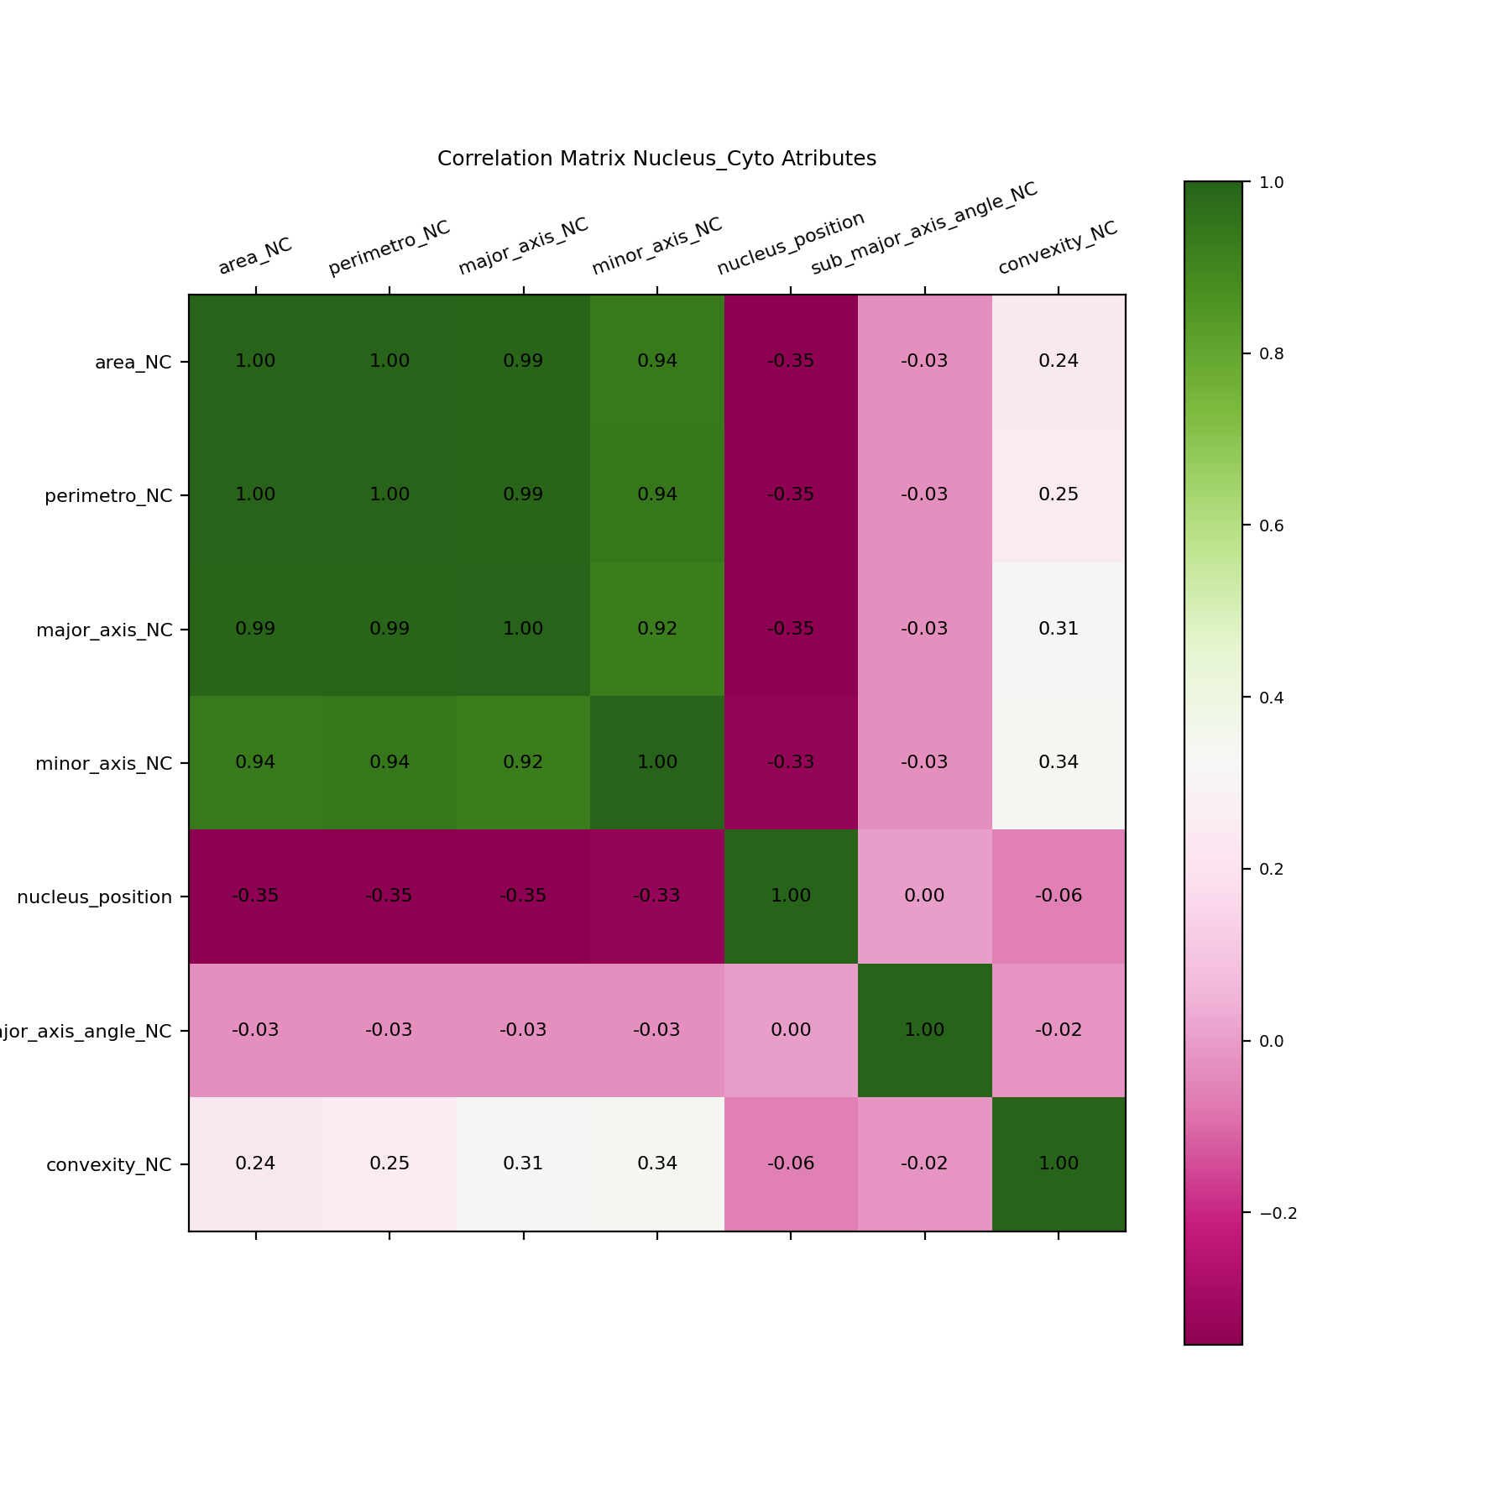

**Consideration:** the above matrix shows high correlation among the features representing a size ratio between the nucleus and cytoplasm :

**area_NC**  (will be used) , perimeter_NC, major_axis_NC , minor_axis_NC

### Boxplots distribution per Bethesda classes

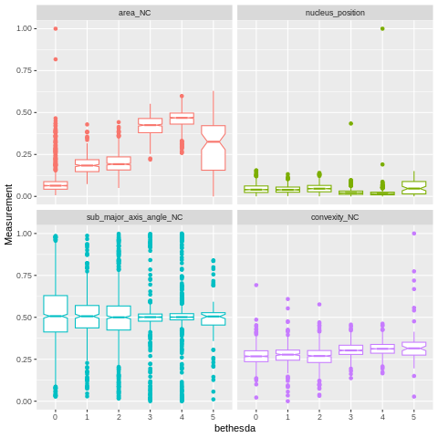

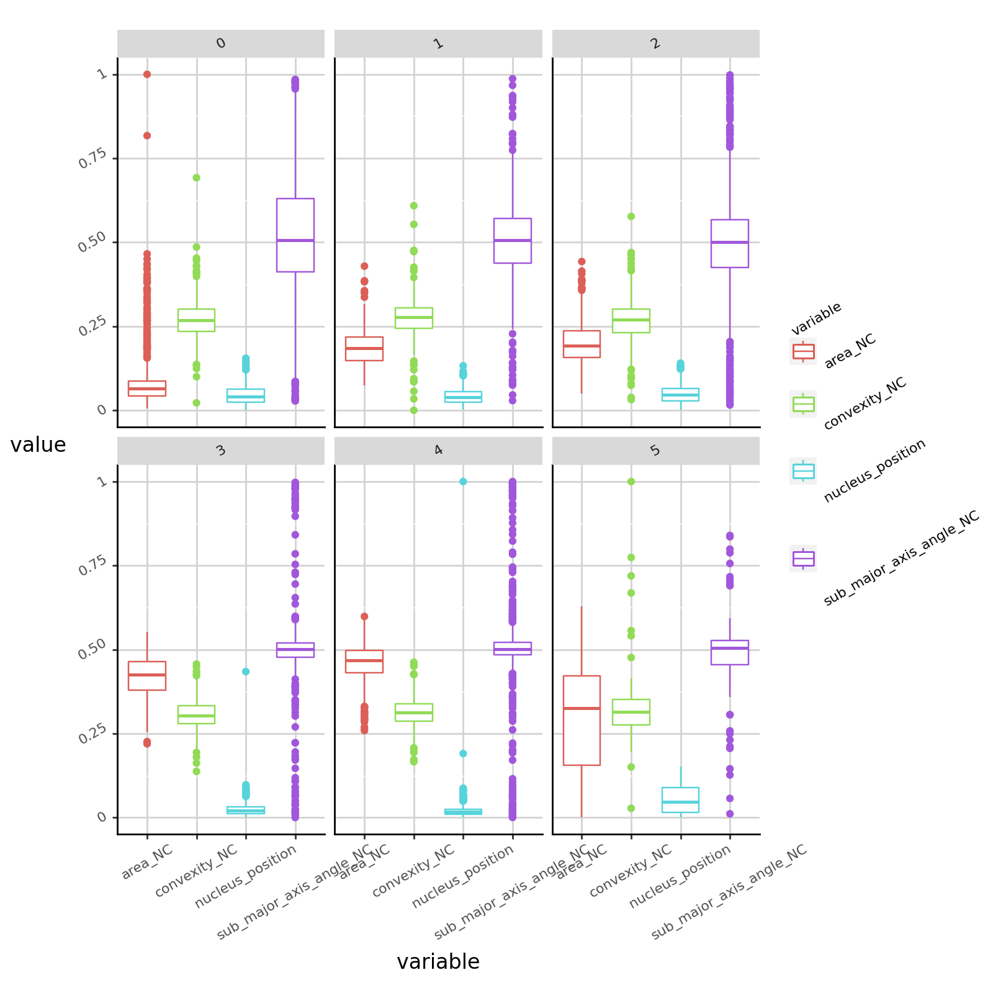

### T-Test

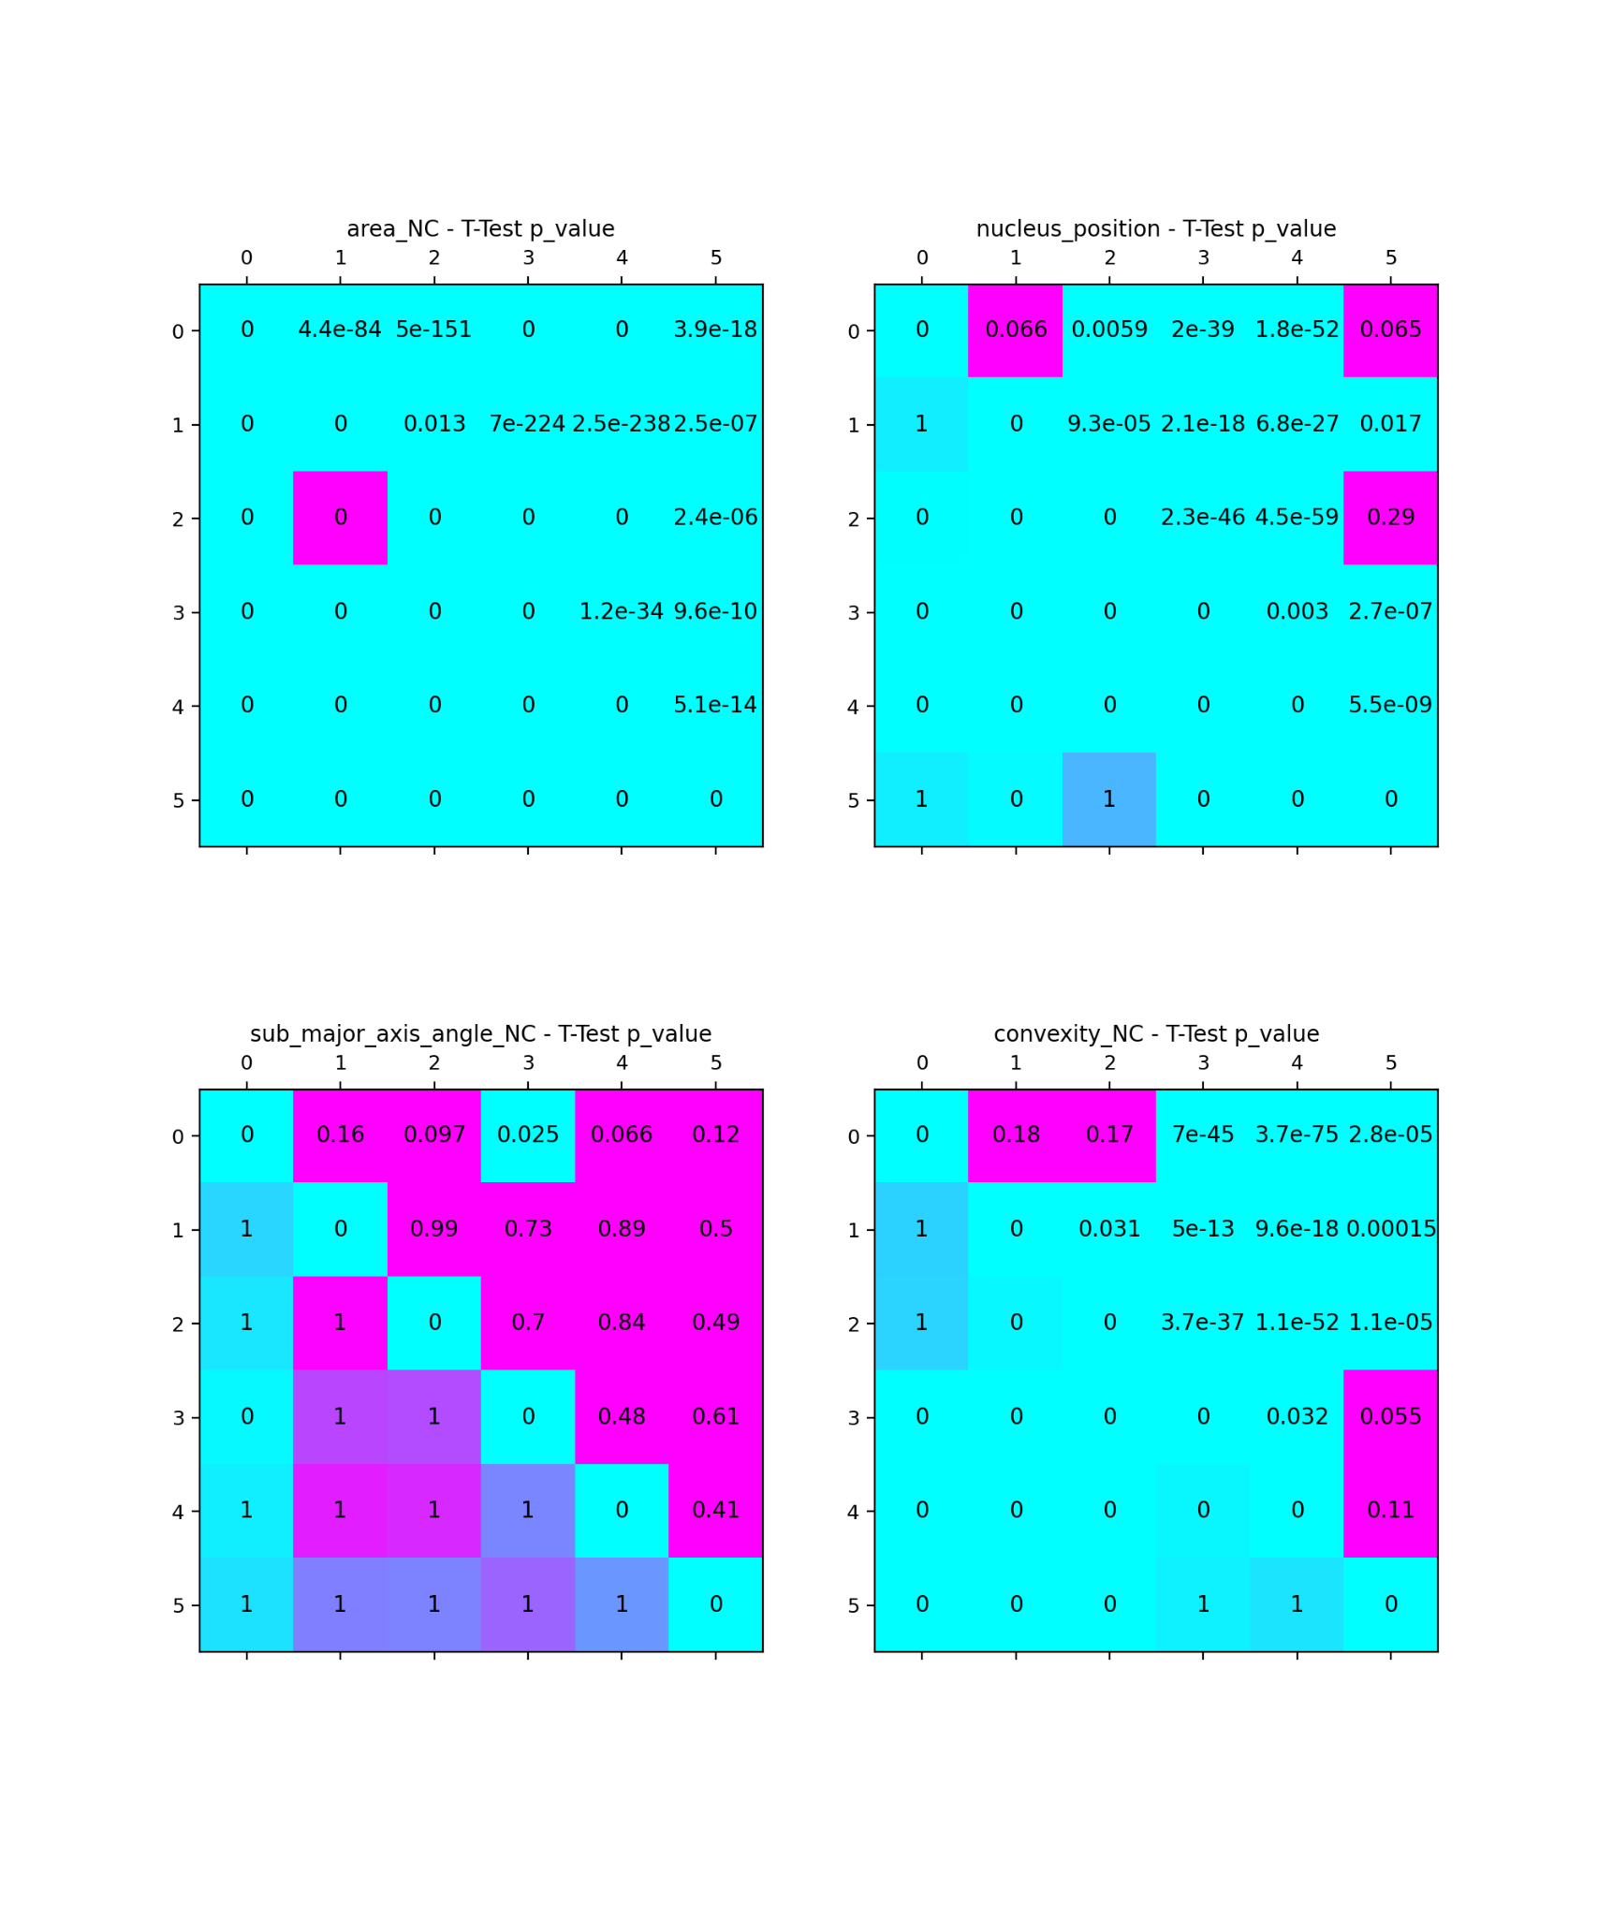

**Consideration:** the follow attribute will be excluded to avoid confusions among normal and abnormal cells or among low grade lesions and high grade lesions

* nucleus position
* sub_major_axis_angle
* convexidade

### **Cell** feature selected

#### **Area_NC** (ration of nucleus and cytoplasm areas)

# Analysis of remaining nuclei, cytoplasm and cells

### Remaining Features:

| Nucleus (A) | **area, extent (Ratio of pixels in the region to pixels in the total bounding box), RA, Use_curv1** |
| --- | --- |
| Cytoplasm (B) | **solidity (Ratio of pixels in the region to pixels of the convex hull image), major_axis** |
| Cell (C) | **area_NC** |

### 

### Density distribution

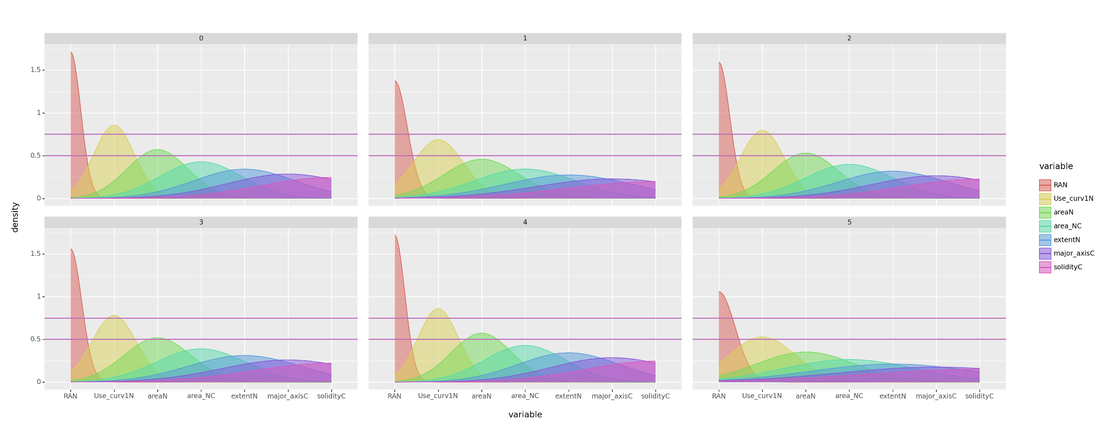

**Consideration:** very similar distributions  **0-4 (normal and HSIL), 2-3 (ASCUS and ASCH)**

### Pairwise density distribution

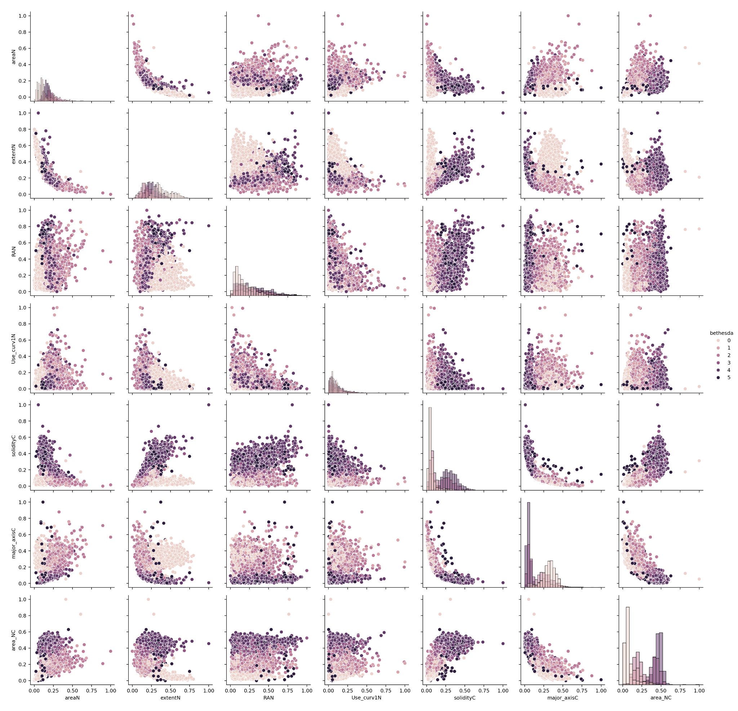

# Classification (KNN, SVM)

* KNN (2 neighboors): 0.6180904522613065 with 80% of test data

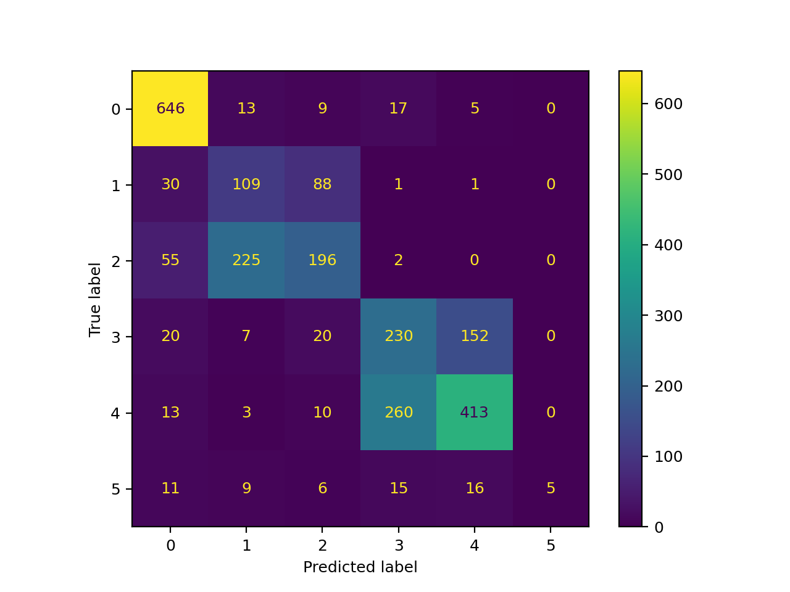

* SVN: 0.7125193199381762 with 40% of test data

